Performance Guidelines



*MOGA Game Controllers for Mobile Devices*

Guidelines for

MOGA Controller Implementation

For Game App Publisher / Developers

___________________________________

Version 1.0

February 19th, 2013

BDA, Inc.

15525 Woodinville Redmond Road NE

Woodinville, WA 98072

## History:

|  |  |  |  |  |
| --- | --- | --- | --- | --- |
| Version | Author | Date | Changes | Affecting |
| 1.0 | MCS | 19 February 2013 | Initial Release | All |

# General Elements

### Introduction

We here at MOGA are excited to introduce to you our mobile gaming controllers, the MOGA Pro and MOGA Pocket. Press, retailer and consumer expectation for MOGA controller functionality will be extremely high for every new MOGA Enhanced title. As a result, our internal teams will prioritize testing and feedback on these titles. We’d like to see the developers of MOGA Enhanced apps fully-utilize the extra buttons on the MOGA Pro controller while also providing an equal gaming experience with the MOGA Pocket controller.

Our priorities concerning optimal integration of MOGA Controllers into new MOGA Enhanced apps are:

1. A true console-like gaming experience, familiar to most video gamers today.
2. Consistent user experience, on both the MOGA Pro and MOGA Pocket.
3. Standardized button usage throughout games within the same genre.
4. Provide a more user-friendly “pick-up-and-play” experience when compared to the inconsistent implementations of HID-compliant gaming controller schemes.
5. Fully-utilize the extra buttons on the MOGA Pro controller while also providing an equal gaming experience with the MOGA Pocket controller.

MOGA Enhanced apps that exhibit thorough implementation of the MOGA controller will be considered our “priority titles” which we will use during press, marketing and consumer engagements. It’s very important that these titles offer an ideal MOGA Enhanced experience.

Please let us know schedules for the updates of your apps – both testing builds to conduct QA on as well as expected updates to Google Play. We’d like to have builds for internal review ASAP.

If you need additional assistance or information during MOGA controller integration, don’t hesitate to ask. Your MOGA Enhanced title(s) are our top priority and we’re here to help. We’re very much looking forward to marketing (and playing) these games with both MOGA controllers.

### MOGA Controller Integration Guidelines

The purpose of this document is to assist with the implementation of the MOGA controllers into title(s). Some of the basic guidelines covered below are:

1. Detection of the specific connected MOGA controller, (MOGA Pocket or MOGA Pro).
2. Addition of the MOGA controller graphics into the title’s Settings/Controls/Info section.
3. Appropriate button re-mapping of specific actions from the MOGA Pocket to the MOGA Pro, to provide the best user experience.
   1. Most button mappings on the MOGA Pocket controller for the L/R shoulder buttons should map to the L2/R2 triggers on the MOGA Pro controller. Examples:
      1. Shooter/Action/FPS game: If on the MOGA Pocket, the “Fire Weapon” action is mapped to the R shoulder button and the “Aim/Zoom” action is mapped to the L shoulder button, then on the MOGA Pro we recommend that the “Fire Weapon” action be mapped to the R2 Trigger and the “Aim/Zoom” action be mapped to the L2 Trigger.
      2. Driving game: If on the MOGA Pocket, the “Gas/Accelerate” action is mapped to the R shoulder button and the “Brake” action is mapped to the L shoulder button, then on the MOGA Pro we recommend that the “Gas/Accelerate” action be mapped to the R2 Trigger and the “Brake” action be mapped to the L2 Trigger.
      3. The new L1/R1 shoulder buttons of the MOGA Pro should be utilized for secondary gameplay functions/actions.
   2. All games that use the Analog Left stick on the MOGA Pocket should also use the Analog Left stick on the MOGA Pro. The D-Pad on the MOGA Pro could be utilized for other specific actions (Like “Look left/right/behind” or “Select weapons”, etc.).
4. To maintain uniform playability using either MOGA controller, functions mapped to the extra buttons/inputs on the MOGA Pro, including; The D-Pad, the L1/R1 shoulder buttons, and the L3/R3 “stick click” buttons, could be available on the MOGA Pocket using certain button combinations (explained below).
5. The “Read Me.pdf” file within the MOGA Pro SDK (available from the MOGA Developer site by applying here: <http://developer.powera.com> ), contains the updated SDK installation procedures and further required development instructions.

### Game App Descriptions in Google Play and Other Storefronts

Include the following text string in your Game App Description on your storefront listing, “Optimized for MOGA Controllers”.

Publishers / Developers should contact their MOGA Account Manager regarding questions concerning the content listed in the MOGA Pivot App, or contact us at [devinfo@MOGAanywhere.com](mailto:devinfo@MOGAanywhere.com).

### Controller Usage Tutorials for Game Play

As with all quality game play, the Gamer needs to know how to play the game. At a minimum, the Game App must have a graphic of the controls and how they are mapped to actions and events within the Game App. It is preferable and highly recommended that the MOGA controls are explained in the same fashion (graphics, animations, etc.) as they are for stand-alone device game play.

The graphic files of the MOGA Pocket and the MOGA Pro Controller are available for all Game App Publishers / Developers from the MOGA Developer Portal, starting here: <http://developer.powera.com/>

### Game Setup, Configuration and Menus

It is expected that all Game Apps will play with the stand-alone Android Device if no MOGA Controller is present and the libraries in the updated MOGA SDK provide the auto-detect functions to know when the controller is present. When the MOGA Pocket Controller is detected, the game should:

1. Play completely with all appropriate controls on the MOGA Pocket Controller.
2. Display MOGA Pocket controller layout graphics within any intro screens, tutorials and the Settings/Help menus.

When the MOGA Pro Controller is detected, the game should:

1. Play completely with all appropriate controls on the MOGA Pro Controller.
2. Display MOGA Pro controller layout graphics within any intro screens, tutorials and the Settings/Help menus.

Specific controller use / assignment guidelines for menu navigation and for gameplay are listed in the tables below.

### Recommended Assignment of MOGA Pro Controller Functions

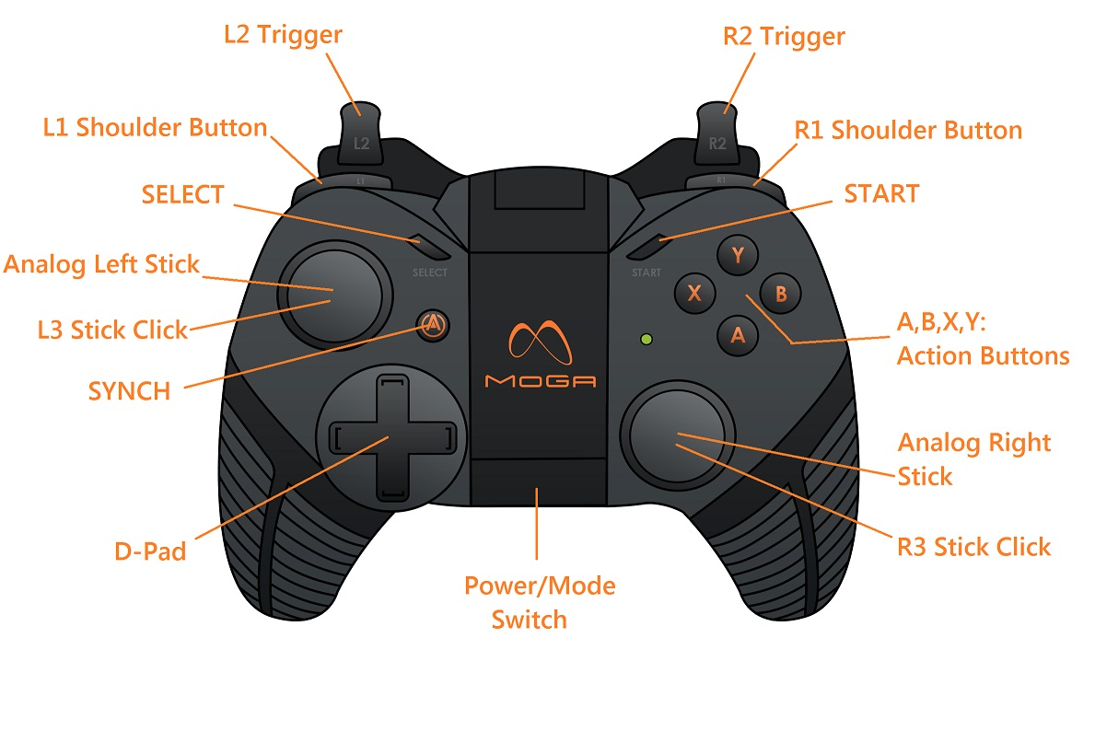

|  |  |  |
| --- | --- | --- |
| Input | Menu Usage Example | Gameplay Usage Example |
| Analog Left | For menus with many options use the degree of Analog value to increase or decrease speed of navigation. | Movement/Steering |
| Analog Right | For menus with many options use the degree of Analog value to increase or decrease speed of navigation. | Aiming/Throttle/Free-Look |
| L2 Trigger | Rotate list of options Left / Up | Shooter: Aim/Zoom, or Secondary Fire  Driving: Brake  Etc: Secondary action in 2-stick games |
| R2 Trigger | Rotate list of options Right / Down | Shooter: Fire, Driving: Gas  Etc: Primary action in 2-stick games |
| A | Accept Menu selection highlight | Primary Action in gameplay, can be different than the R2 trigger |
| B | ‘Back’ in Menus | Secondary Action in gameplay, can be different than the L2 trigger |
| X | - | Tertiary Action in gameplay |
| Y | - | Quaternary Action in gameplay |
| Start | Start Game | Pause/Un-Pause Game |
| Select | Accept Menu selection highlight | Specialized function, Ex: Display scoreboard in multiplayer game |
| D-Pad | Step through Menus, at normal speed | Other in-game functions, or  Movement/Steering |
| L1 Shoulder Button | Rotate list of options Left / Up | Additional in-game action, Ex: Look left in Driving games |
| R1 Shoulder Button | Rotate list of options Right / Down | Additional in-game action, Ex: Look right in Driving games |
| L3 Stick Click | - | Additional in-game action, Ex: Horn in Driving games |
| R3 Stick Click | - | Additional in-game action, Ex: Flash High Beams in Driving games |

### Recommended Assignment of MOGA Pocket Controller Functions

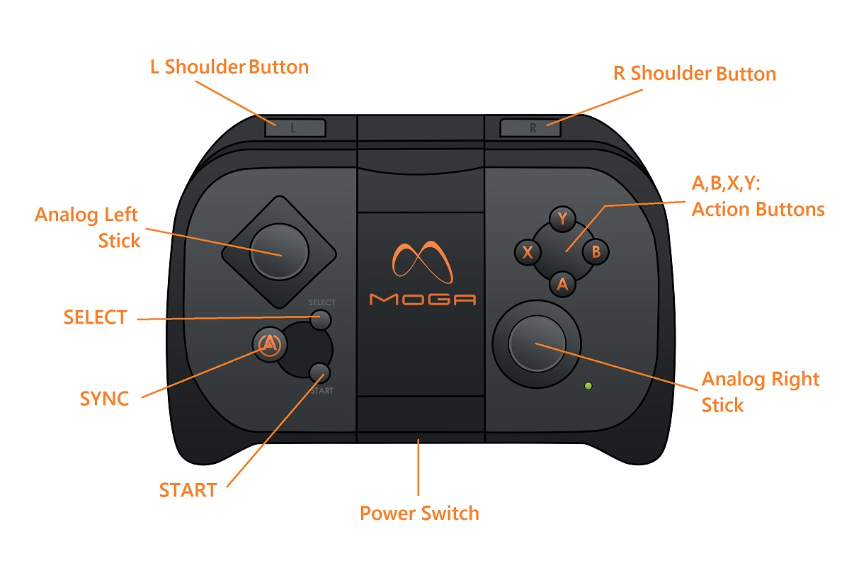

|  |  |  |
| --- | --- | --- |
| Input | Menu Usage Example | Gameplay Usage Example |
| Analog Left | For menus with many options use the degree of Analog value to increase or decrease speed of navigation. | Movement/Steering |
| Analog Right | For menus with many options use the degree of Analog value to increase or decrease speed of navigation. | Aiming/Throttle/Free-Look |
| L Shoulder | Rotate list of options Left / Up | Shooter: Aim/Zoom, or 2ndary Fire  Driving: Brake  Etc: Secondary action in 2-stick games |
| R Shoulder | Rotate list of options Right / Down | Shooter: Fire  Driving: Gas  Etc: Primary action in 2-stick games |
| A | Accept Menu selection highlight | Primary Action in gameplay, can be different than the R shoulder button |
| B | ‘Back’ in Menus | Secondary Action in gameplay, can be different than the L shoulder button |
| X | - | Tertiary Action in gameplay |
| Y | - | Quaternary Action in gameplay |
| Start | Start Game | Pause/Un-Pause Game |
| Select | Accept Menu selection highlight | Specialized function, Ex: Display scoreboard in multiplayer game |

### Additional Function Notes for All MOGA Controllers

1. Screen Time-out
   1. As long as your app is activated from the MOGA Pivot App, the Screen Time-out function will be disabled by the MOGA Pivot App (running in the background).
2. On-Screen Controls
   1. Disable in-game touchscreen controls and remove associated HUD elements when your app detects a connected MOGA controller.

### Preferred Utilization and Implementation of the Extra Buttons/Features of the MOGA Pro

The MOGA Pro offers eight (8) extra inputs over the MOGA Pocket controller. These inputs are:

1. The D-Pad can be used for extra actions if movement is mapped to the Analog Left stick.
   1. Up, Down, Left, Right and Diagonal directions achieved by a combination of two directions, ex: Up-Right, Down-Left, etc.
2. The L1 and R1 shoulder buttons can be used for extra actions, since we recommend that the L2 and R2 triggers be used for the primary/secondary index-finger actions.
3. The Analog Left and Right sticks now click down, as the L3 and R3 “stick clicks”, and can be used for extra actions.

## Direct Correlation Input Mapping, MOGA Pro to MOGA Pocket

In a majority of MOGA Enhanced games, the following table details direct correlation between inputs from the MOGA Pro to the MOGA Pocket.

|  |  |  |
| --- | --- | --- |
| MOGA Pro | to | MOGA Pocket |
| Analog Left stick | **>** | Analog Left stick |
| Analog Right stick | **>** | Analog Right stick |
| R2 Trigger | **>** | R Shoulder Button |
| L2 Trigger | **>** | L Shoulder Button |
| A,B,X,Y Buttons | **>** | A,B,X,Y Buttons |
| Start | **>** | Start |
| Select | **>** | Select |

### Additional Input Mapping, from MOGA Pocket to MOGA Pro

As the MOGA Pocket doesn’t have the additional inputs on the MOGA Pro, this section will display some suggestions on how to use a combination of MOGA Pocket inputs to effectively mimic these MOGA Pro inputs. Depending on the in-game actions within your title, the L shoulder button on the MOGA Pocket could be used as a modifier or “shift” function. If the L shoulder button is utilized for an essential in-game action (i.e. braking in driving games), then the Select button may be a more logical choice for the shift function. For other situations, a combination of simultaneous button presses or a double-tap of a single button may be the best option to simulate one of these MOGA Pro inputs.

|  |  |  |
| --- | --- | --- |
| MOGA Pro Additional Inputs | to | MOGA Pocket Virtual Inputs |
| D-Pad | **>** | L shoulder button + A,B,X,Y buttons  L shoulder button + Analog Right stick  Select button + A,B,X,Y buttons  Select button + Analog Right stick  Simultaneous A,B,X,Y button combo |
| L1 shoulder button | **>** | Select button + L shoulder button  Select button + Analog Right stick (left)  X button + L shoulder button  Double-tap L shoulder button  Simultaneous A,B,X,Y 2-button combo |
| R1 shoulder button | **>** | Select button + R shoulder button  Select button + Analog Right stick (right)  X button + R shoulder button  Double-tap R shoulder button  Simultaneous A,B,X,Y 2-button combo |
| L3 stick click | **>** | X button + L shoulder button  Double-tap L shoulder button  Directionally double-tap Analog Left stick  Simultaneous A,B,X,Y 2-button combo |
| R3 stick click | **>** | X button + R shoulder button  Double-tap R shoulder button  Directionally double-tap Analog Right stick  Simultaneous A,B,X,Y 2-button combo |

When you utilize the extra inputs on the MOGA Pro to include some new, in-game actions to improve the user-experience of your game, we fully support your efforts to implement these extra features. As stated before, it is appreciated if the MOGA Pocket controller is also able to provide a similar experience with your game when compared to the MOGA Pro controller. With any new actions mapped to the MOGA Pro, they should be described in the Controls screen on the MOGA Pro graphic. Additionally, these same actions should be given proper inputs via the MOGA Pocket, while also being described in the Controls screen on the MOGA Pocket graphic.

On the following pages are some examples of MOGA controller button layouts for popular game genres. They contain our recommended input mappings for each controller and are to be used as guidelines for you to implement into your specific title(s).

## Detailed Examples of Typical Game Genre Controller Layouts

# Sim-Style Racing/Driving

|  |  |  |
| --- | --- | --- |
| **MOGA Pro Input** | **MOGA Controller**  **In-Game Action** | **MOGA Pocket Input** |
| Analog Left stick | Steer | Analog Left stick |
| Analog Right stick | Rotate View Around Car,  Rear View,  Change Gears (Manual Trans.) | Analog Right stick |
| L2 trigger | Brake/Reverse | L shoulder button |
| R2 trigger | Gas | R shoulder button |
| A button | Nitrous/Turbo | A button |
| B button | E-Brake | B button |
| X button | Change View  (In-Car -> Behind Car) | X button |
| Y button | Rear View | Y button |
| Start button | Pause/Un-pause | Start button |
| Select button | Hud/Map/Leaderboard | Select button |

|  |  |  |
| --- | --- | --- |
| **MOGA Pro Input** | **MOGA Controller**  **In-Game Action** | **MOGA Pocket Input** |
| D-Pad | Change View | X button |
| L1 shoulder button | E-Brake | B button |
| R1 shoulder button | Nitrous/Turbo | A button |
| L3 stick click | Horn | A+X buttons |
| R3 stick click | Flash High Beams | B+Y Buttons |

# Arcade/Action “Kart” Racing

|  |  |  |  |
| --- | --- | --- | --- |
| **MOGA Pro Input** | **MOGA Controller**  **In-Game Action** | | **MOGA Pocket Input** |
| Analog Left stick | Steer | | Analog Left stick |
| Analog Right stick | Rotate View Around Car  Rear View, Bump Opponents | | Analog Right stick |
| L2 trigger | Brake/Reverse | | L shoulder button |
| R2 trigger | Gas | | R shoulder button |
| A button | Use Item/Fire Weapon | | A button |
| B button | Nitrous/Turbo | | B button |
| X button | Jump/Drift | | X button |
| Y button | Rear View | | Y button |
| Start button | Pause/Un-pause | | Start button |
| Select button | Hud/Map/Leaderboard | Alternate Input Shift | Select button |

|  |  |  |  |
| --- | --- | --- | --- |
| **MOGA Pro Input** | **MOGA Controller**  **In-Game Action** | | **MOGA Pocket Input** |
| D-Pad | Select Specific Items/Weapons | n/a | n/a |
| L1 shoulder button | Use Item/Fire Weapon | | A button |
| R1 shoulder button | Scroll Items/Weapons | | Select+A button |
| L3 stick click | Horn | | Double-Tap Analog Right stick (up) |
| R3 stick click | Taunt Animation | | Double-Tap Analog Right stick (down) |

# Combat Flying Sim (Airplane)

|  |  |  |  |
| --- | --- | --- | --- |
| **MOGA Pro Input** | **MOGA Controller**  **In-Game Action** | | **MOGA Pocket Input** |
| Analog Left stick | Flight Control Stick | | Analog Left stick |
| Analog Right stick | Throttle and Yaw | | Analog Right stick |
| L2 trigger | Fire Missiles/Rockets | Alternate Input Shift | L shoulder button |
| “ | “ | Fire Missiles/Rockets | L+R shoulder buttons |
| R2 trigger | Fire Gun | | R shoulder button |
| A button | Target Nearest Enemy | | A button |
| B button | Target Next Enemy | | B button |
| X button | Change Missile/Rocket Type | | X button |
| Y button | Rear View | | Y button |
| Start button | Pause/Un-pause | | Start button |
| Select button | Map | | Select button |

|  |  |  |
| --- | --- | --- |
| **MOGA Pro Input** | **MOGA Controller**  **In-Game Action** | **MOGA Pocket Input** |
| D-Pad | Flaps/L-Gear/ECM/Flares | L shoulder+A,B,X,Y buttons |
| L1 shoulder button | Look Left | L shoulder+Analog Right stick (Pull Left) |
| R1 shoulder button | Look Right | L shoulder+Analog Right stick (Pull Right) |
| L3 stick click | Change View | L shoulder+Analog Right stick (Push Up) |
| R3 stick click | Wingman Commands Menu | L shoulder+Analog Right stick (Pull Down) |

# Combat Shooter

|  |  |  |  |
| --- | --- | --- | --- |
| **MOGA Pro Input** | **MOGA Controller**  **In-Game Action** | | **MOGA Pocket Input** |
| Analog Left stick | Movement | | Analog Left stick |
| Analog Right stick | Look/Aim | | Analog Right stick |
| L2 trigger | Zoom/Aim Down Sights | | L shoulder button |
| R2 trigger | Fire | | R shoulder button |
| A button | Jump | | A button |
| B button | Crouch | | B button |
| X button | Reload | | X button |
| Y button | Change Weapon | | Y button |
| Start button | Pause/Un-pause | | Start button |
| Select button | Show Scoreboard | Show Scoreboard (tap)  Alternate Input Shift (hold) | Select button |

|  |  |  |
| --- | --- | --- |
| **MOGA Pro Input** | **MOGA Controller**  **In-Game Action** | **MOGA Pocket Input** |
| D-Pad | Quick Weapon Selection | Select+A,B,X,Y buttons |
| L1 shoulder button | Use Equipment/Special | Hold Y, then press  L shoulder button. |
| R1 shoulder button | Throw Grenade | Hold Y, then press  R shoulder button. |
| L3 stick click | Sprint | Double-Tap Up on  Analog Left stick |
| R3 stick click | Melee | Double-Tap X Button |

# Twin-Stick Shooter

|  |  |  |
| --- | --- | --- |
| **MOGA Pro Input** | **MOGA Controller**  **In-Game Action** | **MOGA Pocket Input** |
| Analog Left stick | Movement | Analog Left stick |
| Analog Right stick | Shoot | Analog Right stick |
| L2 trigger | Special/Grenade | L shoulder button |
| R2 trigger | Change Weapon | R shoulder button |
| A button | Activate (Doors, etc) | A button |
| B button | Enter/Exit Vehicle | B button |
| X button | Change Special/Grenade | X button |
| Y button | Change View | Y button |
| Start button | Pause/Un-pause | Start button |
| Select button | Menu Select | Select button |

|  |  |  |
| --- | --- | --- |
| **MOGA Pro Input** | **MOGA Controller**  **In-Game Action** | **MOGA Pocket Input** |
| D-Pad | Quick Weapon Selection | Select+Analog Right stick |
| L1 shoulder button | Move Faster | Select+L shoulder button |
| R1 shoulder button | Move Slower | Select+R shoulder button |
| L3 stick click | Ultra-Weapon | A+X buttons |
| R3 stick click | Take Screenshot | Select+L+R shoulder buttons |

# Side-Scroller Beat-em-Up

|  |  |  |
| --- | --- | --- |
| **MOGA Pro Input** | **MOGA Controller**  **In-Game Action** | **MOGA Pocket Input** |
| Analog Left stick | Movement | Analog Left stick |
| Analog Right stick | Move Camera | Analog Right stick |
| L2 trigger | Run | L shoulder button |
| R2 trigger | Special Attack | R shoulder button |
| A button | Kick/Attack | A button |
| B button | Punch/2ndary Attack | B button |
| X button | Jump | X button |
| Y button | Pickup/Drop Weapon | Y button |
| Start button | Pause/Un-pause | Start button |
| Select button | Menu Select | Select button |

|  |  |  |
| --- | --- | --- |
| **MOGA Pro Input** | **MOGA Controller**  **In-Game Action** | **MOGA Pocket Input** |
| D-Pad | Quick Weapon Selection | Select+A,B,X,Y buttons |
| L1 shoulder button | Rising Jump-Kick | X+A button |
| R1 shoulder button | Backwards Attack | A+B button |
| L3 stick click | Ultra-Attack | L+R shoulder buttons |
| R3 stick click | Take Screenshot | Select+L Shoulder button |

# Street 1vs1 Fighting

|  |  |  |
| --- | --- | --- |
| **MOGA Pro Input** | **MOGA Controller**  **In-Game Action** | **MOGA Pocket Input** |
| Analog Left stick | Movement | Analog Left stick |
| Analog Right stick | Taunts | Analog Right stick |
| L2 trigger | Heavy Punch | L shoulder button |
| R2 trigger | Heavy Kick | R shoulder button |
| A button | Light Kick | A button |
| B button | Medium Kick | B button |
| X button | Light Punch | X button |
| Y button | Medium Punch | Y button |
| Start button | Pause/Un-pause | Start button |
| Select button | Menu Select | Select button |

|  |  |  |
| --- | --- | --- |
| **MOGA Pro Input** | **MOGA Controller**  **In-Game Action** | **MOGA Pocket Input** |
| D-Pad | Movement | Select+A,B,X,Y buttons |
| L1 shoulder button | Special Kick | X+L shoulder button |
| R1 shoulder button | Special Punch | A+R shoulder button |
| L3 stick click | Sprint | Double-Tap on  Analog Left stick |
| R3 stick click | Take Screenshot | Select+L+R Shoulder button |

# Shoot ‘em Up (SHMUP)

|  |  |  |
| --- | --- | --- |
| **MOGA Pro Input** | **MOGA Controller**  **In-Game Action** | **MOGA Pocket Input** |
| Analog Left stick | Movement | Analog Left stick |
| Analog Right stick | Quick Dodge | Analog Right stick |
| L2 trigger | Missiles/2ndary Weapon | L shoulder button |
| R2 trigger | Fire Main weapon | R shoulder button |
| A button | Activate | A button |
| B button | Bomb | B button |
| X button | Switch Weapon | X button |
| Y button | Switch 2ndary Weapon | Y button |
| Start button | Pause/Un-pause | Start button |
| Select button | Menu Select | Select button |

|  |  |  |
| --- | --- | --- |
| **MOGA Pro Input** | **MOGA Controller**  **In-Game Action** | **MOGA Pocket Input** |
| D-Pad | Quick Weapon Selection | Select+A,B,X,Y buttons |
| L1 shoulder button | Main Rapid Fire | Hold L shoulder button |
| R1 shoulder button | 2ndary Rapid Fire | Hold R shoulder button |
| L3 stick click | Ultra Weapon | A+X buttons |
| R3 stick click | Take Screenshot | Select+L+R Shoulder button |

# Side-Scrolling Platformer

|  |  |  |
| --- | --- | --- |
| **MOGA Pro Input** | **MOGA Controller**  **In-Game Action** | **MOGA Pocket Input** |
| Analog Left stick | Movement | Analog Left stick |
| Analog Right stick | Aim Weapon/Item | Analog Right stick |
| L2 trigger | Change Weapon/Item | L shoulder button |
| R2 trigger | Fire Weapon /Use Item | R shoulder button |
| A button | Jump | A button |
| B button | Punch/Kick | B button |
| X button | Run | X button |
| Y button | Pickup/Drop Item | Y button |
| Start button | Pause/Un-pause | Start button |
| Select button | Menu Select | Select button |

|  |  |  |
| --- | --- | --- |
| **MOGA Pro Input** | **MOGA Controller**  **In-Game Action** | **MOGA Pocket Input** |
| D-Pad | Quick Item Selection | Select+A,B,X,Y buttons |
| L1 shoulder button | Look Back | Select+ L shoulder button |
| R1 shoulder button | Look Forward | Select+R shoulder button |
| L3 stick click | Super Jump | A+X buttons |
| R3 stick click | Take Screenshot | Select+L+R Shoulder button |

CHECKLIST FOR MOGA POCKET and MOGA PRO INTEGRATION QA CERTIFICATION

**USER TUTORIALS & CONTROL LAYOUTS FOR MOGA CONTROLLER OPERATION**

|  |  |  |
| --- | --- | --- |
| Control Assignment Map Graphic Present for MOGA Pocket within Intro/Tutorial and Settings/Help Menus | **YES** | **NO** |
| Control Assignment Map Graphic Present for MOGA Pro within Intro/Tutorial and Settings/Help Menus | **YES** | **NO** |
| User Tutorial in Same Style as Original Game Build but with Specific Instructions for MOGA Pro | **YES** | **NO** |
| User Tutorial in Same Style as Original Game Build but with Specific Instructions for MOGA Pocket | **YES** | **NO** |
| Comments: | | |

**GAME / DEVICE OPERATIONS**

|  |  |  |
| --- | --- | --- |
| Game will play in both Landscape Orientations if device flipped. | **YES** | **NO** |
| Game receives “Lost MOGA Connection” message and notifies User | **YES** | **NO** |
| Game performs to all normal Android standards and expectations (with or without MOGA Controller present) | **YES** | **NO** |
| Game detects and enables MOGA Controller functions for MOGA Pro | **YES** | **NO** |
| Game detects and enables MOGA Controller functions for MOGA Pocket | **YES** | **NO** |
| Comments: | | |

**GAME SETUP AND CONFIGURATION**

|  |  |  |
| --- | --- | --- |
| All configuration and setup menus are enabled for Landscape Viewing | **YES** | **NO** |
| All menus and options are able to be navigated with Left Analog Stick and the physical D-Pad on the MOGA Pro | **YES** | **NO** |
| All menus and options are able to be navigated with Left Analog Stick on the MOGA Pocket | **YES** | **NO** |
| Menu Selections are with "A" Button and "Select" Button | **YES** | **NO** |
| Menus are backed up to Previous Menu with "B" Button | **YES** | **NO** |
| App can be exited via Main Menu with “B” Button, back to the Pivot App,. | **YES** | **NO** |
| Vigorous Motion Sensing in-game actions are disabled while MOGA Controller is Actively Connected. (No “shake device” commands to player). | **YES** | **NO** |
| In-game messages that refer to touch screen commands updated to MOGA Controller commands. Ex “Touch screen to continue” becomes “Press A Button to continue”. | **YES** | **NO** |
| Touch Screen Use of Menus in Configuration and Setup can be active as long as MOGA Controller is also active | **YES** | **NO** |
| User-Customizable Sensitivity Settings available for the Analog sticks, especially for Driving, Flying, and Shooter games. | **YES** | **NO** |
| User-Customizable Inverted-Look Settings available for the Analog sticks, especially for Flight, Shooter and Action games. (Pull down to look up, and vice-versa) | **YES** | **NO** |
| User-Customizable Swap Analog Stick Function Settings, to allow the Analog Left and Analog Right stick to Swap functions. | **YES** | **NO** |
| Comments: | | |

**GAME PLAY ORIGINAL MOGA**

|  |  |  |
| --- | --- | --- |
| START Button will pause and resume game play | **YES** | **NO** |
| SELECT Button will select menu options | **YES** | **NO** |
| Left Analog Stick is used as a "D-Pad" -or- | **YES** | **NO** |
| Left Analog Stick is used as a full analog joystick (direction and magnitude) | **YES** | **NO** |
| Right Analog Stick is used as a "D-Pad" -or- | **YES** | **NO** |
| Right Analog Stick is used a full analog joystick (direction and magnitude) | **YES** | **NO** |
| All control buttons (A,B,X,Y,R,L) operate and perform as expected | **YES** | **NO** |
| Comments: | | |

**GAME PLAY MOGA PRO**

|  |  |  |
| --- | --- | --- |
| START Button will pause and resume game play | **YES** | **NO** |
| SELECT Button will select menu options | **YES** | **NO** |
| Left Analog Stick is used as a full analog joystick (direction and magnitude) | **YES** | **NO** |
| Right Analog Stick is used a full analog joystick (direction and magnitude) | **YES** | **NO** |
| All control buttons (A,B,X,Y, R1, L1, R2, L2, R3, L3) operate and perform as expected | **YES** | **NO** |
| Physical D-Pad is used for D-pad commands (Up, Down, Left, Right), for other in-game actions, or as a duplicate of other inputs, such as the A,B,X,Y Buttons. | **YES** | **NO** |
| All MOGA Pro unique actions can be replicated on an MOGA Pocket controller. | **YES** | **NO** |
| Comments: | | |

**GAME EXIT**

|  |  |  |
| --- | --- | --- |
| If game offers an customizable controller layout for the User Profile, then MOGA Controller Settings saved on Exit | **YES** | **NO** |
| Motion Sensing re-enabled when MOGA controller disconnected | **YES** | **NO** |
| Touch Screen operation re-enabled when MOGA controller disconnected | **YES** | **NO** |
| All other system changes are restored to original pre-game settings | **YES** | **NO** |
| Comments: | | |